DGIWG - 915
DGIWG Register Maintenance Procedures
Document type: Enterprise
Document date: 20 June 2018
Edition: 2.0.0
Supersedes: This document supersedes DGIWG 915 Ed. 1.0, Defense Defense Register Maintenance Procedures, 26 January 2010.
Responsible Party: Defense Geospatial Information Working Group (DGIWG)
Audience: This document is approved for public release
Abstract: This document describes how to manage a DGIWG Registry with its Register(s) based on the ISO 19135-1:2015.
Copyright: (C) Copyright DGIWG, some rights reserved - (CC) (By:) Attribution
You are free:
- to copy, distribute, display, and perform/execute the work
- to make derivative works
- to make commercial use of the work
Under the following conditions:
- (By:) Attribution. You must give the original author (DGIWG) credit.
- For any reuse or distribution, you must make clear to others the license terms of this work.
- Any of these conditions can be waived if you get permission from the copyright holder DGIWG.
Contents
1 Scope 1
2 References (normative) 1
3 Terms and Definitions 1
3.1 General terms and definitions 1
3.2 DGIWG specific terms and definitions 2
4 Introduction 2
5 Roles 2
5.1 Register Owner 4
5.2 Register Manager (RegMan) 4
5.3 Submitter/Submitting Organisation 4
5.4 Authorised National Representative (ANR) 4
5.5 National Representative (NR) 5
5.6 Responsible Representative (RR) 5
5.7 Control Body (CB) 5
5.8 Registry manager 5
5.9 Subject Matter Expert (SME) 5
5.10 Maintenance Team (MT) 6
6 Register Item 6
7 Access to the DGIWG Registry 7
8 Change Management 7
8.1 Submission Process 8
8.2 Approval Process 9
8.2.1 Approval process in a Core Register 9
8.2.2 Approval Process in an Extended Register 10
8.3 Ballot session 11
8.3.1 General process 11
8.3.2 Special cases 11
8.3.3 Voting Summary 12
8.4 Proposal List 13
8.5 Withdrawal 14
9 Appeal Process 14

Scope
This document provides specific management procedures to be followed when establishing, maintaining and publishing DGIWG Registers of unique, unambiguous and permanent identifiers and meanings assigned to geographic information items within a DGIWG Registry.

References (normative)
[1] DGIWG 905 2.0.0 – DGIWG Directives
[2] ISO 19135-1:2015 – Geographic information – Procedures for item registration Part 1: Fundamentals
[3] ISO 19135:2005 – Geographic information – Procedures for item registration

Terms and Definitions

General terms and definitions
Core Register schema: Contains the minimum of what is required to set up a register conformant to ISO 19135-1 and is the “relaxed” version of the model in ISO 19135:2005. [ISO 19135-1:2015]
Extended Register schema: Extends the Core Register minimum requirements to include additional elements from ISO 19135:2005, ensuring backwards compatibility.
Multi-part Register: Contains items from different classes organised into sections based on the information elements recorded for each class.
Proposal: Submitted by a person or organisation (as specified by the Register owner) to propose changes to the content of the Register.
Proposal lifecycle: Specified process by which new Register items are added or existing items are modified.
Proposal List: A list of the submitted Proposals.
Register item class: Set of items with common properties. [ISO 19135-1:2015]
Register item clarification: Non-substantive change to a Register item. [ISO 19135-1:2015]
Register item retirement: Declaration that a Register item is no longer suitable for use in the production of new data. [ISO 19135-1:2015]
Register item supersession: Declaration that a Register item has been retired and replaced by one or more new items. [ISO 19135-1:2015]
Simple Register: A Register containing items of a single item class. Since the same information elements are recorded for all items on the Register, this is the simplest structure to manage.

DGIWG specific terms and definitions
The following additional terms and definitions are specific to DGIWG.
DGIWG Client: A Defence group or agency which has engaged the services of DGIWG to address one or more interoperability needs/requirements for geospatial information.
NOTE: Clients are defined as users (consumers) of standards. Clients may be Participants or Associates. [DGIWG 905]
DGIWG Liaison: An organisation or group that has entered into a Technical Cooperation Agreement (TCA) with DGIWG.
NOTE: Liaisons are Associates with Technical Cooperation Agreements. [DGIWG 905]

Introduction
This document describes the management processes for maintaining a DGIWG Registry and its Registers. Although the procedures for item registration are based on and regulated by ISO 19135-1:2015, the scope of this document has been expanded to include DGIWG-specific roles and responsibilities in the management and change process of DGIWG Registers.

Roles
A Registry may contain one or more Registers. For each Register, roles need to be defined and “linked” to a specific entity (person). Multiple roles can be undertaken by a single entity, or performed across multiple Registers if required. Submitting organisations may forward a Proposal via their Authorised National Representative (ANR), or via the National Representative (NR). The Register User exists “outside” the Registry and Register, and only accesses the content of the Register. According to ISO 19135-1:2015, a Control Body is not required for a “Core Register”. Figure 1 illustrates the roles in a “Core Register”.

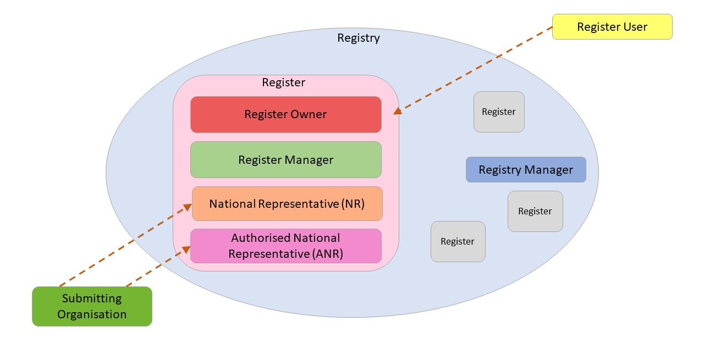
Figure 1: Roles in a “Core Register”

In contrast, Figure 2 outlines the roles within an “Extended Register”, where a Control Body is required and the Subject Matter Experts (SME) can be consulted during the discussion of a Proposal.

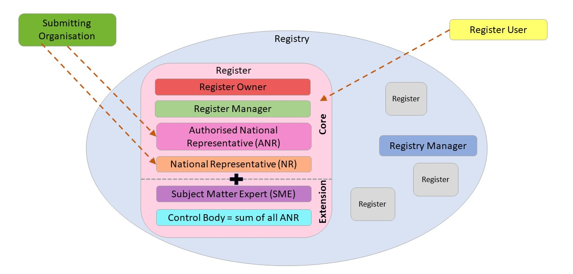
Figure 2: Roles in an “Extended Register”
Note to Figure 2: The SME only participates if there is a Control Body. For further clarification, see chapter 5.9.

Register Owner
DGIWG and its Management Team are the owners of the DGIWG Registry and its Registers. Technical and management Register responsibilities are delegated to the relative DGIWG team leads. The Register Owner has the primary responsibility for the management, dissemination and intellectual content of the Registers which are established.
Depending on the type of Register, the Register Owner decides whether a Control Body (5.7) is required and if so appoints the Control Body.
The Register Owner appoints a Register Manager for a Register.

Register Manager (RegMan)
The Register Manager has the responsibility to manage Proposals, maintain the content of Registers and make changes in the Registers. If a Control Body is necessary, the Register Manager makes any necessary changes in the Registers once approved by the Control Body. A Register Manager can also propose the following changes if necessary, to enhance the consistency or integrity of the Registers` content:
- add Proposals to the Proposal List (if they were submitted by a DGIWG Client or Liaison) (5.3). In doing so, the RegMan becomes a Responsible Representative (5.6);
- edit Proposals;
- view management records in the Register; and
- view voting results within the voting period.

Submitter/Submitting Organisation
A Submitter is a person or an organisation acting on behalf of a DGIWG Member Nation, a DGIWG Client or a DGIWG Liaison. This person or organisation proposes changes to the content of a Register to an Authorised National Representative (5.4) or a National Representative (5.5) or, in the case of a Client, to the Register Manager (5.2).

Authorised National Representative (ANR)
The designated representative of a DGIWG Member Nation (and if a Control Body is required, then the voting member in the Control Body), will be responsible for the following tasks:
- adding Proposals to the Proposal List, thus becoming an RR;
- authorising NRs and if necessary, SMEs (5.8).
If a Control Body is required, the ANR will have the following additional tasks:
- discuss, vote on and appeal Proposals;
- view management records in the Register.

National Representative (NR)
The Member NR is a person designated as the principal point of contact. The ANR delegates authority to the NR to receive and forward Proposals from a Submitter. The NR has the responsibility to:
- add Proposals to the Proposal List, thus becoming an RR;
- If a Control Body is required:
- discuss Proposals; and
- view management records in the Register.

Responsible Representative (RR)
An ANR, NR or the RegMan who adds a Proposal to the Proposal List becomes a Responsible Representative (RR) for that single Proposal.
The RR is the individual responsible for all processes throughout the Proposal lifecycle.

Control Body (CB)
The Control Body consists of the ANRs of all DGIWG Member Nations.
Its role is to decide on the acceptability of Proposals for changes to the content of a Register.
The establishment of a Control Body is not essential but will depend upon the type of Register.
A Control Body may not be required for simple Registers.

Registry manager
DGIWG and its Management Team are responsible for the day-to-day management of the DGIWG Registry.
The Registry manager ensures the integrity of any Register held in the Registry and provides means for electronic access to the Registry for Register managers, Control Body members and Register Users.

Subject Matter Expert (SME)
An SME participates in the Proposal discussion sessions making recommendations and answering questions on the Proposal, thereby supporting the ANR in the Control Body. If a Control Body is not required for a Register, then an SME will not be required. The SME must be authorised by their Authorised National Representative (ANR) to, where necessary:
- discuss Proposals within the discussion period; and
- view management records (for example, discussion and voting results) in the Register.

Maintenance Team (MT)
The Maintenance Team is only necessary if a Control Body (CB) is required. It consists of the CB, NRs, SMEs and the RegMan and is responsible for evaluating Proposals. The RegMan is the lead of the Maintenance Team and the NRs and SMEs provide recommendations to the CB.
Figure 3 outlines these roles (5.1 – 5.8) and illustrates that the Submitting Organisation itself exists “outside” the DGIWG working procedure. Any suggestions for change in a Register must be submitted via an ANR, NR or in the case of a DGIWG Client or Liaison, directly to the RegMan. The ANR, NR or in the case of a DGIWG Client or Liaison, RegMan will add the Proposal to the Proposal List and thereby become the Responsible Representative and the first point of contact for that particular Proposal throughout its lifecycle.
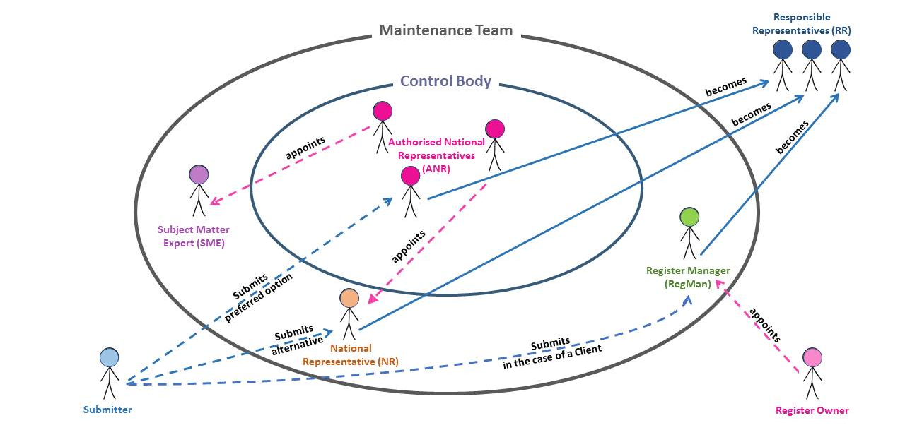
Figure 3: Maintenance Team

Register Item
The Register item (extended or core ones) can vary between Registers. For each DGIWG Register, it will be necessary to specify whether Register contents are provided by means of a database, an excel-file, a tool or other mechanism.

Access to the DGIWG Registry
The DGIWG Registry should be accessible via an online entry point.
The specification for different levels of access to the specific Register(s) of the DGIWG Registry is specified in detail in separate documents.

Change Management
This section describes the lifecycle procedures for the Proposal as specified by DGIWG. For each Register, a specific timeline for the registration process (Figure 4) shall be defined.
NOTE: The registration process may be considerably shorter in the case of a Core Register where neither a Control Body nor Subject Matter Experts are required.
Further details for each DGIWG Register are specified in separate documents.
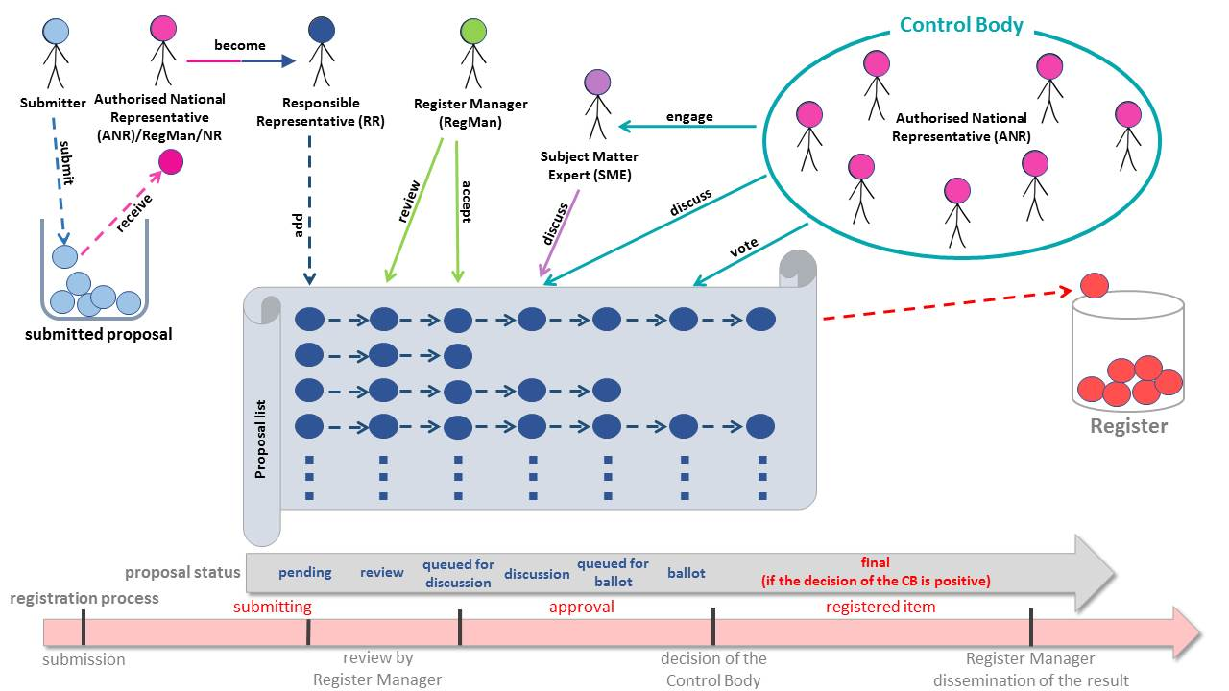
Figure 4: Registration Process of a New Proposal in an “Extended Register”
Figure 4 outlines the process of a new Proposal, from submission through to registration of the item in a Register. From the top left of Figure 4, the submitting organisation (outside DGIWG) submits a Proposal, thereby instructing its respective ANR (or NR) to set in motion the subsequent processes. From left to right at the top of Figure 4, the roles and scope of influence throughout the process are shown. An NR may also receive the Proposal and add it to the Proposal List. Both NRs and SMEs may discuss Proposals during the approval process however since NRs are not part of the CB they cannot vote during balloting. The Proposal statuses and phases are outlined at the bottom of Figure 4. For each Register, appropriate time periods for each phase shall be defined.

Submission Process
Figure 5 describes the submission process as a conceptual model using UML notation for both Core and Extended Registers. The process involves the following steps:
- Proposals are developed by the Submitter through an external process;
- The Submitter will either forward the Proposal to their ANR or NR (who will ultimately forward the Proposal to the RegMan by adding it to the Proposal List);
- A DGIWG Client (acting as a Submitter) will forward the Proposal directly to the RegMan;
- The ANR/NR/RegMan who receives the Proposal becomes RR for this Proposal;
- The RR will ensure that the Proposal is complete;
- The RR will add the Proposal to the Proposal List;
- Depending on the implemented system, the RegMan will either receive a notification that a new Proposal has been added to the Proposal List or they must to manually check for new Proposals regularly.
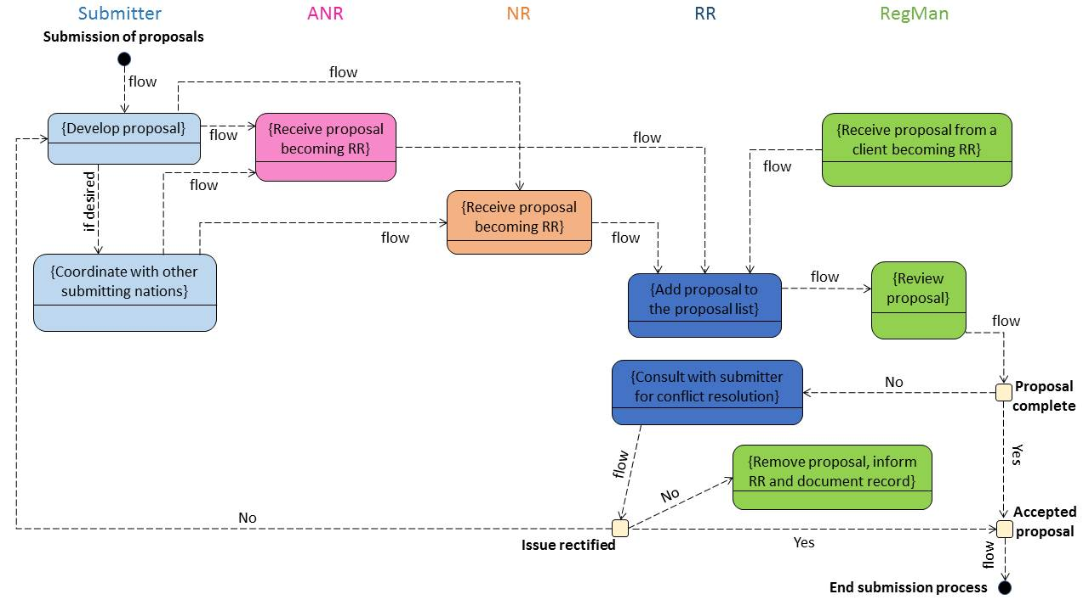
Figure 5: Submission Process

Approval Process

Approval process in a Core Register
The approval process for a Core Register is illustrated in Figure 6. The following workflow applies:
- After the RegMan has accepted a Proposal;
  - the RegMan will determine whether the Proposal is for the clarification or retirement of a Register item, and will update the status and content accordingly; or
  - if the Proposal is for registration of a new item or modification of an existing Register item, the RegMan will insert the new or superseding item into the Register and update the status and content; and finally,
  - the RegMan will disseminate the registration of the new Register item.

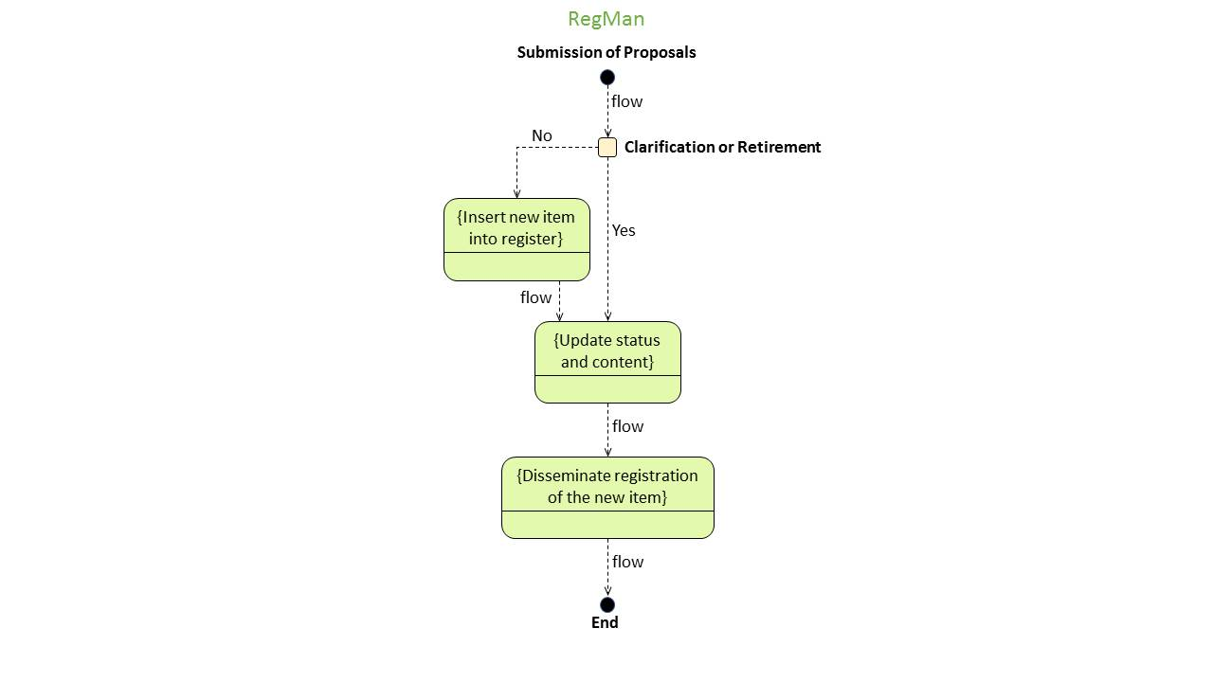
Figure 6: Approval Process in a “Core Register”

Approval Process in an Extended Register
The approval process for an Extended Register is illustrated in Figure 7 with the following steps:
- After the RegMan has accepted a Proposal:
  - the RegMan will decide if the Proposal is for clarification or retirement of a Register item, and if so queue the Proposal on the Proposal List for the approval process; or
  - if the Proposal is for the registration of a new item or modification of an existing Register item, the RegMan will insert the new or superseding item into the Register and then queue the Proposal on the Proposal List for the approval process.
- All Proposals in the discussion queue will go to the discussion session on the date of the next ballot. The starting date and duration of the discussion period is specified for each Register;
- The RegMan will notify all ANRs, NRs and SMEs once the discussion session has opened. ANRs, NRs and SMEs may comment on the Proposal;
- The RegMan will document a discussion record;
- The RR will review the discussion record in consultation with the Submitter; and
- The starting date and duration of the review period is specified for each Register.

Ballot session

General process
  - Following the review of the discussion record, the voting period will begin, with the time limit of the ballot session specified for each Register;
  - Each DGIWG Member Nation represented by an ANR will have one vote;
  - There are three voting terms:
    - Yes
    - No
    - No Business Interest (NBI)
  - If a Member Nation has no interest in the Proposal, e.g. the Nation does not have a Navy so it has no interest in maritime topics, rather than not voting casting a No Business Interest vote will show a willingness to participate;
  - At least three ANRs must participate in the voting procedure for the vote to be considered valid;
  - If there are less than three votes, the Proposals are re-submitted for voting in the next voting cycle;
  - If there are three or more votes, there must be at least two “Yes” votes for a Proposal to be accepted;
  - A one-vote majority is sufficient to accept or decline a Proposal; and
  - Voting No is a rejection of the Proposal for inclusion into the relevant Register.

Special cases
  - In a tie situation (e.g. two Yes votes and two No votes) the No Business Interest votes will count as Yes votes, i.e. two Yes, two No and two No Business Interest means approval of the Proposal. However, there is one exception to this rule: If the ANR who is also RR for the Proposal changed his position during the voting cycle and finally votes No to his own Proposal, the No Business Interest votes expressed will also count as No Vote;
  - Where there is a tie and no No Business Interest votes have been cast, the Proposal goes back for re-work and is carried over to the next voting cycle;
  - The No Business Interest vote removes the ambiguity of the “abstain” vote by making it clear that the voting member does not require the Proposed Register item, but has no objection to its inclusion within the relevant Register; and
  - An ANR voting No shall give a justification in the designated field on the ballot page.

Voting Summary
    - Minimum 3 votes
    - At least 2 Yes
    - 1 vote majority
    - NBI will usually count Yes in a tie situation of Yes/No
    - In the case of not enough votes or a tie with no NBI=> resubmission into next voting cycle.
  - After the voting has ended for each Proposal the RegMan will notify all ANRs and NRs of the result;
  - The RRs must inform the Submitter of the result; and
  - The voting results will be archived in the respective DGIWG website and specific Register and will be visible to the ANRs.
- The RegMan will update the status and content of the item to be registered; and finally,
- The RegMan will disseminate the results of the approval process.
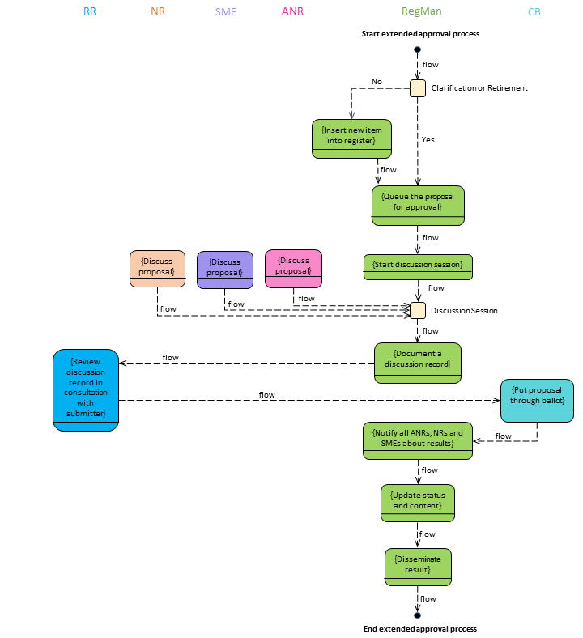
Figure 7: Approval Process in an “Extended Register”

Proposal List
For further detail on the Proposal List processes, please refer to Figure 4 at the beginning of section 8. In summary:
- The Proposal List is hosted on an online entry point and in the respective DGIWG Register;
- Proposals will queue for the upcoming ballot discussion process;
- In the discussion session, the Proposal List will allow the ANRs, the NRs and the SMEs to comment on the Proposal;
- After the discussion process, the Proposal will be prepared for a vote;
- Voted Proposals on the Proposal List will be archived.

Withdrawal
During the approval process, the Submitter may decide to withdraw a Proposal at any time.
- The Submitter will announce the withdrawal via the RR for the Proposal;
- The RR will forward the withdrawal of the Proposal to the RegMan;
- The RegMan will change the status of the proposed item to “retired”.
NOTE: Although the item may never have previously existed formally in the schema, after its withdrawal it will be allocated the status “retired”. Withdrawn Proposals shall be stored on a separate list for documentation process.

Appeal Process
An appeal process for a Register is not a requirement. The requirement for a formal appeal process will depend upon the type of Register. An appeal process is only suitable for an Extended Register. Figure 8 displays the conceptual UML “flow” for an appeal process in an Extended Register.
Further details on the appeal process are specified for each Register and are listed below:
- After the voting results are published via RR to the Submitter there is a specified period (specified by the CB) within which an appeal may be raised;
- If the Submitter disagrees with the result of the approval process, an appeal will be submitted from their RR;
- The RR of the Proposal will forward the appeal to the Control Body;
- The Control Body will evaluate the appeal as follows:
  - If the Control Body resolves the issue, the RegMan will update the status and disseminate the final result; or
  - If the issue remains unresolved, the Control Body will forward the appeal via the RegMan to the Register owner. The Register owner will make a decision on the appeal and will inform the RegMan of their decision. The RegMan will update the status and disseminate the final result.
- After dissemination of the final result the appeal process ends.
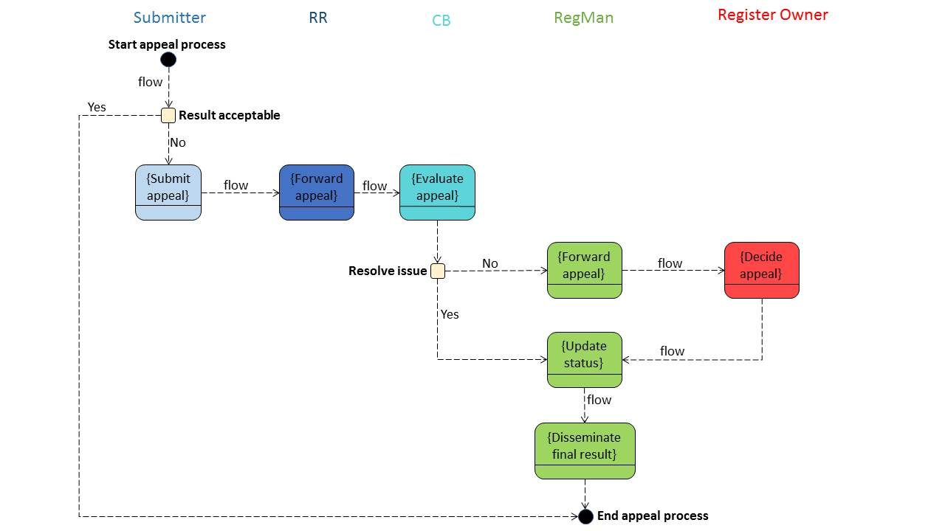
Figure 8: Appeal Process in an “Extended Register”

The role is usually the respective project Maintenance Team lead within DGIWG.
The Control Body (CB) decides which clients/liaisons are eligible to submit a Proposal.
See Fig. 3, Fig. 4 and Fig. 5.
The RegMan will review the Proposal for completeness, and return the Proposals to the submitting organisation if the Proposal is incomplete or if the submitting organisation is not qualified. The RegMan will check whether the Proposal is suitable for the selected item class. They will also check the semantic consistency, especially for similarities to existing concepts, possible overlapping meanings etc. If the Proposal is acceptable, the RegMan will initiate the approval process.

