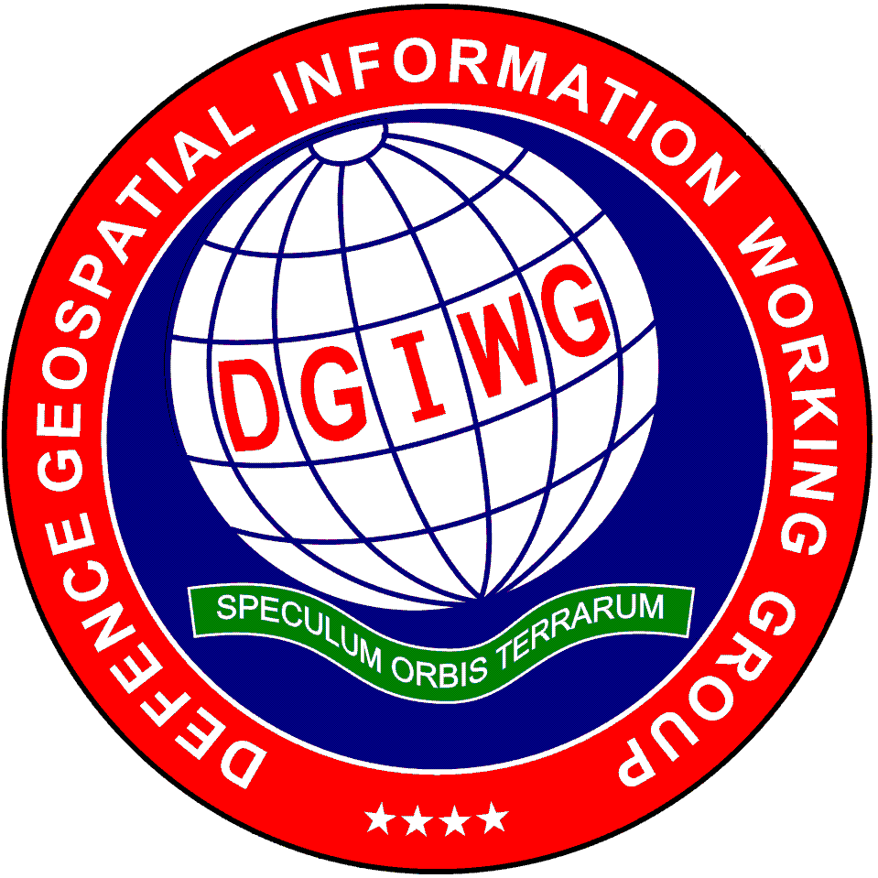
“Delivering Military Advantage through multi-national geospatial interoperability”

DGIWG 908
Portrayal Roadmap

Edition: 4.0
Date: 24 April 2023

Document Type: ENT
Publication Date: 24 April 2023
Edition: 4.0
Edition Date: 20 April 2023
Document status: DGIWG Publication
Responsible Party: DGIWG
Audience: This document is approved for public release and is available on the DGIWG website, https://www.dgiwg.org/
Abstract: This document summarises the development and maintenance activities that the DGIWG P4 Portrayal Technical Panel will be undertaking in the next 24 months as well a technical assessment of emerging trends and concepts that are relevant to the Defence Geospatial community.

Copyright: © Copyright DGIWG. Licensed under the terms in CC BY 4.0

© DGIWG All rights reserved. No part of this document may be reproduced, stored in a retrieval system, used commercially, adapted or transmitted in any form or by any means electronic, photocopying, or otherwise, without the prior permission of the responsible party. The above statement does not apply to participating organisations.

Table of Contents

1 Introduction 1
2 Scope 1
3 References 2
3.1 DGIWG Documents 2
3.2 DGIWG Standards 2
3.3 International Organization for Standardization (ISO) references 2
3.4 Open Geospatial Consortium (OGC) references 2
3.5 North Atlantic Treaty Organization (NATO) references 2
3.6 Other references 3
3.7 National 3
4 Terms and abbreviations 3
5 Target Architecture 3
5.1 Static Portrayal 3
5.2 Dynamic Portrayal 4
5.3 Symbology register 4
6 Current responsibilities 4
7 Current and Planned Activities 5
7.1 Maintenance Work 5
7.2 Development Work 6
8 Emerging Concepts and Associate Standards 6
8.1 Medium term assessment 6
8.2 Long Term Assessment 7
ANNEX A Artefact Responsibility 9

Table of Tables
Table 1: List of abbreviations and acronyms 3
Table 2: Current responsibilities 4
Table 3: Maintenance Activities 5
Table 4: Development Activities 6
Table A 1: Artefacts for which P4 is responsible 9

Executive Summary
This document describes the aims and objectives of the DGIWG Portrayal Technical Panel (P4) outlining its current and planned activities and deliverables within the short, medium, and long term time horizons.
The document complements the DGIWG Geospatial Reference Architecture and other DGIWG Panel Roadmaps in supporting the DGIWG Program of Work.
The document is reviewed and updated annually to ensure currency.
ii. Contributing participants
Nation | Parent Organisation
CZE | Geographic Service of the Armed Forces of the Czech Republic, Office of Military Geography and Hydrometeorology
FRA | Institut national de l’information géographique et forestière (IGN)  Direction Générale de l’Armement (DGA)
GBR | UK Strategic Command, Ministry of Defence
USA | National Geospatial-Intelligence Agency (NGA)  Army Geospatial Centre (AGC)

iii. Document points of contact
Person | Organisation | Email
James Prain | DGIWG | secretary@dgiwg.org
Lubos Belka | DGIWG Portrayal Technical Panel Chair | lubos.belka@army.cz

iv. Revision history
Date | Edition | Primary clauses modified | Description
Jan 2022 | 4.0 (WD1) | Original Document | New roadmap template initial population by P4
Feb 2023 | 4.0 (FD1) | Original Document | New roadmap template fully populated by P4
Apr 2023 | 4.0. (DP) | DGIWG Publication.  All Clauses. Final draft revised and harmonized. P0 Quality Control completed | Edition 4.0 replaces edition 3.0 published in July 2019

Introduction
The purpose of the Portrayal Panel (P4) is to create and maintain a set of symbols for geospatial products that are produced in accordance with the standardisation artefacts under the Defence Geospatial Information Framework (DGIF).

Scope
        - DGIWG portrayal work focuses on symbology, encoding labelling definition and ruleset creation, together with their maintenance, encoding and distribution.

        - The Panel synchronizes efforts with all DGIWG Technical Panels to support geospatial production, DPS development and web services implementation.

        - As products are defined, specific computer readable cartographic rulesets will be created to support digital displays, or for paper products as required. Common symbols and marginalia information for set products will significantly reduce the interpretive errors created by the end user as products are exchanged amongst multinational forces.

        - The Portrayal (P4) Roadmap summarises the development and maintenance activities that the DGIWG P4 team will be undertaking in the next 24 months, together with a technical assessment of emerging trends and concepts that are relevant to the Defence Geospatial community. The technical assessment provides DGIWG with a brief understanding and view of:
        - What the trends are and how they work
        - Potential’ trend benefits to the Defence Geospatial community
        - Potential trend effects on the DGRA
        - An indication of the maturity level of the trends, i.e., is it just emerging, or is it mature enough to warrant further consideration and development by DGIWG?
        - The technical assessment takes both a medium (3-5 year) and long term (6-10 year) view of the trends, as well as their development and potential impact on the Defence Geospatial community.

        - This document has the following key sections:
  - Target Vision: Description of how ‘good’ looks like, both now (‘as is’) and over the coming years (‘should be’).
- Current Responsibilities: Summarising P4’s maintenance responsibilities for existing DGIWG documents.
- Current and Planned Activities: Summary of P4’s planned technical work for the next 24 months.
- Emerging Concepts and Associated Standards: An assessment of emerging technical trends and their potential benefit to the Defence Geospatial community.

References

DGIWG Documents
          - DGIWG Requirements Tracker, 2022
          - DGIWG 902, Program of Work (PoW), 2022
          - DGIWG 930, Business Manual, 2022
          - DGIWG 933, DGIWG Geospatial Reference Architecture (DGRA), 2022
          - DGIWG 904, Defence Geospatial Standards Baseline (DGSB)

DGIWG Standards
          - DGIWG 128, Implementation Guide for General Symbology Styles and Encoding
          - DGIWG 130, Web Symbology
          - DGIWG 131, Printing Colours for Defence Geospatial Products
          - DGIWG 252, Data Product Specification (DPS) for Defence Topographic Map 1:50,000
          - DGIWG 256, Data Product Specification (DPS) for Defence City Map
          - DGIWG 258, Data Product Specification (DPS) for Defence Joint Operations Graphic Air

International Organization for Standardization (ISO) references
          - ISO 19117:2012, Geographic information - Portrayal

Open Geospatial Consortium (OGC) references
          - OGC 05-078r4, Styled Layer Descriptor Profile of the Web Map Service Implementation Specification v.1.1.0 (revision 4) (2007)
          - OGC 05-077r4, Symbology Encoding Implementation Specification v1.1.0 (revision 4) (2006)
          - OGC 18-067r3, Symbology Conceptual Core Model (SymCore) (2020)

North Atlantic Treaty Organization (NATO) references
          - STANAG 3675 Ed: 2 Symbols on Land Maps, Aeronautical and Special Naval Charts (2001)
          - STANAG 3676 Ed: 3 Marginal information on Land Maps, Aeronautical Charts and Photomaps
          - STANAG 2592 Ed 2 NATO Geospatial Information Framework (NGIF)
          - AGeoP-11 Ed: B Ver.1, STD, NATO Geospatial Information Framework (NGIF) (2018)
          - AGeoP-11.3 Ed: A Ver.1, SRD, GEOTIFF Raster Format Specification in NATO Environment

Other references
          - W3C, Scalable Vector Graphics (SVG) 1.1 Specification (2011)
          - IHO Geospatial Information Registry (version 3.1)

National
          - US DOD MIL-STD-3060 with Change 2, Foundation GEOINT Digital Print and Color Separation 2021

Terms and abbreviations
Table 1 - List of abbreviations and acronyms
Acronym | Definition
AC | Annotation Catalogue
AML | Additional Military Layers
API | Application Programming Interface
COP | Common Operational Picture
DCM | Defence City Map
DGIF | Defence Geospatial Information Framework
DGIWG | Defence Geospatial Information Working Group
DGRA | DGIWG Geospatial Reference Architecture
DJOG(A) | Defence Joint Operations Graphic Air 1:250,000
DPS / DPSs | Data Product Specification / Data Product Specifications
DTM50 | Defence Topographic Map 1:50,000
IHO | International Hydrographic Organization
ISO | International Organization for Standardization
NGIF | NATO Geospatial Information Framework
OGC | Open Geospatial Consortium
PC | Portrayal Catalogue
STANAG | Standardization Agreement
SVG | Scalable Vector Graphics
TPC | Tactical Pilotage Chart

Target Architecture

Static Portrayal
          - P4 addresses portrayal aspects of Data Product Specifications (DPSs) for hardcopy maps in coordination with the Vector Panel (P1). The vision is that DPS for DCM, DTM50, DJOG(A), and TPC will be completed in the near term (up to 3 years). These include.

Dynamic Portrayal
          - Symbology sets for vector data have been developed and maintained. The first general set was developed and issued as DGIWG 130 Web Symbology in 2019. This should be revised and updated regularly to address user requirements.
          - Moreover, other symbology sets for specific conditions, applications, devices, and missions should be developed and maintained.

Symbology register
          - P4 is aiming for the symbology register to be available via the web environment.
          - The register will contain:
- symbol objects;
- symbol design library; and
- standardised colour definitions.
- symbol assignment for products (hardcopy maps, web services)
          - The register will allow:
- visualisation of symbols;
- filtering according to a specific product, geometry, baselines, etc.;
- downloading of symbols in machine readable formats such as SVG; and
- preview proposed changes.

Current responsibilities

        - P4 is responsible for the maintenance and update of a number of DGIWG’s standard profiles and documents. A full list of these and their update date can be found in Annex A of this document.
Table 2 – Current responsibilities
Doc ID | Name | Task summary | Document type  (Standard, Guidance note etc.) | Due Date
109 | Portrayal Standard for MGCP data | This document standardises marks and symbols used to portray Real World Objects on topographic maps. It also provides the Symbol Rules  encoding for portraying MGCP TRD4 Data.  We recommend to sunset this document when the DTM50 DPS version 1.3 is adopted for production. | Standard | ---
118 | Portrayal Registry Service | This document provides an interface-independent information model for a Portrayal Registry.  It is NOT planned to update. | Standard | ---
128 | Implementation Guide for General Symbology Styles and Encoding | This is an implementation guide for general symbology encoding. | Guidance | 2023
130 | Web Symbology | This document defines a common set of symbols which support the portrayal of feature data as web services, across a full range of zoom levels. | Standard | 2019
131 | Printing Colours for Defence Geospatial Products | This document ensures consistent definitions, terminology, and procedures for the hardcopy printing of NATO geospatial products (maps and charts). | Standard | 2023
256 | DPS for the DCM | In collaboration with P1. P4 addresses portrayal aspects. | Standard | 2023
258 | DPS for the DJOG(A) | In collaboration with P1. P4 addresses portrayal aspects. | Standard | 2023
908 | Portrayal Roadmap | Completion in the new template. | Enterprise document | 2023

        - In general, P4 is responsible for surveying and tracking the symbology and portrayal domain to incorporate new types of standards, formats and practices which could offer enhancements and advantages to DGIWG member nations.

Current and Planned Activities
This Section contains a summary of the technical work being undertaken by P4.

Maintenance Work
          - The following table lists the DGIWG documents that P4 plans to review in the next 24 months.
Table 3 - Maintenance Activities
Doc ID | Name | Task summary | Document type  (Standard, Guidance note, etc.) | Last time reviewed
130 | Web Symbology | P4 to review and, if appropriate, update | Standard | 07/2019
131 | Printing Colours for Defence Geospatial Products | P4 to review and, if appropriate, update | Standard | 01/2023
908 | Portrayal Roadmap | P4 to review and, if appropriate, update | Roadmap | 01/2023

Development Work
          - The following table lists the technical developments that P4 plans to undertake in the next 24 months.
Table 4 - Development Activities
Task Ref | Task Name | Task summary | Output  (Standard, Guidance note, White paper etc.) | Due Date
P4.05 | Symbol Database / Register | Change management process will be developed and implemented. | Database, register, guidance | 12/2023
P4.07 | STANAG 3675 symbol set | Transfer of symbols from STANAG 3675 will be completed and documented. | Database, report | 02/2023
P1.03 | DCM DPS PC, AC | Portrayal aspects of the DPS development will be addressed. Symbols and their design definition will be uploaded into the Symbol Database. | Standard | 12/2023
P1.05 | DJOG(A) DPS PC, AC | Portrayal aspects of the DPS development will be addressed. Symbols and their design definition will be uploaded into the Symbol Database. | Standard | 12/2023

Emerging Concepts and Associate Standards

Medium term assessment
The key trends identified by P4 which are within scope of its responsibilities, have proven to be more mature, and therefore more likely to affect the Defence Geospatial community. Further work by DGIWG over the next 3-5 years is expected on the following:

Definite Trend 1: Data Product Specifications for additional hardcopy maps
- Description: After the DPSs for DCM, DTM50, DJOG(A) have been completed, additional special (thematic) maps will be standardised. This is applicable for Maps of Military Training Areas at 1:50,000, aeronautical maps/charts, human geography maps, etc.
- Benefits and relevance to the Geospatial Defence Community: Standardisation of additional maps will increase interoperability and common understanding of those products that are used in allied operations.
- Level of Maturity: This is a mature trend and is ready for adoption by the defence community.

Definite Trend 2: Portrayal Register
- Description: Portrayal Register is further developed and includes business rules for labels, scale-based portrayal, machine readable sets of symbols for traditional hardcopy and web symbology (for normal conditions), together with extensibility for other conditions, applications, devices and missions, using tailored portrayal.
- Benefits and relevance to the Geospatial Defence Community: A register of symbol and styling information, leveraging DGIF to enable updateable portrayal along with digital artefacts suitable for rapid implementation.
- Level of Maturity: This is a mature trend and is ready for adoption by the defence community.

Definite Trend 3: Dynamic Portrayal
- Description: Dynamic Portrayal encompasses aspects of portrayal that enables visual adaptive representation across zoom levels. This is achieved through the development of styling rules with appropriate symbol size, geometry, level of feature density and labelling characteristics for digital maps. DGIWG 130 Web Symbology and the DGIWG 128 Implementation Guide for General Symbology Styles and Encoding together lay the groundwork for further development of digital map portrayal standards.
- Benefits and relevance to the Geospatial Defence Community: Dynamic Portrayal will provide visualisation of foundational geospatial data from vector content enabling efficient updates, the ability to obtain attribute information from the data, as well as tailored views for platforms and topography.
- Level of Maturity: This is a mature trend and is ready for adoption by the defence community.

Portrayal for Additional Military Layers
- Description: The concept of Additional Military Layers (AML) originates from within the maritime community. NATO STANAG 7170 defines it as “a unified range of digital geospatial data products designed to satisfy the totality of NATO non navigational maritime defence requirements”. As the broader defence community recognises similar requirements for ground AML, the Defence Geospatial standards community anticipates facilitating the development of additional profiles and symbology styles to support common styles for layers through the registration of symbols and additional documentation.
- Benefits and relevance to the Geospatial Defence Community: AML support beyond the maritime community will facilitate the development of common styling to meet the requirements for a layer for a specific purpose within the digital environment.
- Level of Maturity: This is a mature trend and is ready for adoption by the defence community.

Long Term Assessment
The key trends identified by the P4, which are in scope of its responsibilities, less mature, and therefore unlikely to affect the Defence Geospatial community in the near term, and would require further work by DGIWG in the next 6-10 years are as follows:

Definite Trend 4: 3D portrayal
- Description: 3D display technology is rapidly expanding for both high fidelity and generic users. The internet gaming community and the defence modelling and simulation community are demanding higher quality 3D portrayal while simple 3D globe applications are proliferating in desktop and mobile devices.
- Benefits and relevance to the Geospatial Defence Community: As life cycle replacement of older systems are planned, more and more GIS and mission-command systems are adopting 3D solutions and demanding more from visualisation than simply draping 2D imagery, features and symbology over a 3D terrain mesh. Efforts to mature portrayal capabilities must provide more accurate location information and COP visualisation to display objects on, above or below surface level.
Interoperability for both raster and vector portrayal should support both 2D and 3D portrayal capabilities. Many current GIS and mission command systems primarily use 2D visualisation, especially desktop systems in Command Posts (CPs). 3D globes are becoming more common. Efforts to mature portrayal capabilities will ensure solutions for both 2D and 3D portrayal as vector features have more accurate location information. COP visualisation requirements will include the display of objects on, above, or below surface level.

Definite Trend 5: APIs and Portrayal Registry as a Service
- Description: Application Programming Interfaces (APIs) provide modern resource-centric mechanisms that allow systems to interoperate based on shared resources. OGC API standards build upon and modernize OGC Web Service Standards with implementable “building block” approaches. The draft OGC API – Styles specification, as part of OGCs Open Portrayal Framework is intended to support interoperable portrayal of heterogeneous geospatial data (OGC 19-018) by enabling style sharing, updates, and encoding conversion to support client and server-side rendering of geospatial data which enable and modernize the concept of Portrayal Registry as a service. These capabilities will support military use cases for common visualisation of geospatial information through shared portrayal specifications and symbology configurations.
- Benefits and relevance to the Geospatial Defence Community: APIs allow the Defence Community to exploit pre-prepared “building blocks” for defence applications. Portrayal interoperability will become more common, with the ability to share styling information between different systems. Modernisation of portrayal specifications with symbol registers and catalogued digital styling information will be more implementable using OGC API–Styles resulting in improved analysis, visualisation, and expedited updates to geospatial data with shared styles and published portrayal registers.
- Level of Maturity: Developing Trend that should be on the horizon for adoption by the defence community.

- Artefact Responsibility
Table A1 contains a list of completed DGIWG documents and artefacts that P4 is responsible for maintaining. (Note: this table is extracted from the DGIWG PoW and should not be updated in isolation).
Table A 1: Artefacts for which P4 is responsible
Doc ID | Document Title | Published Date | Edition Date | Review Cycle | Review by Date
109 | Portrayal Standard for MGCP data | 29/05/2015 |  | No update planned | N/A
118 | Portrayal Registry Service | 11/04/2013 |  | No update planned | N/A
128 | Implementation Guide for General Symbology Styles and Encoding | Not published yet |  | 4 years | 2028
130 | Web Symbology | 27/07/2020 |  | 4 years | 2024
131 | Printing Colours for Defence Geospatial Products | 06/12/2022 |  | 2 years | 2024
908 | Portrayal Roadmap | 26/07/2019 |  | annual | 2024

The text comes from DGIWG 930 Business Manual Paragraph 6.2 and the respective Purpose clauses.
The text comes from DGIWG 930 Business Manual Paragraph 6.2 and the respective Scope clauses.

